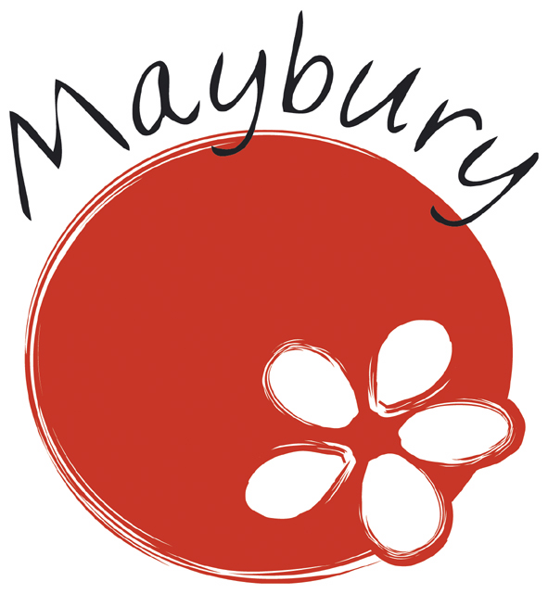

Progression in Reading

Content Domains

Progression in Reading
Content Domains
The content domain sets out the relevant elements from the national curriculum programme of study (2014) for English that are assessed in the English Reading Tests. The test will, over time, sample from each area of the content domain.

The English reading tests will focus on the comprehension elements of the national curriculum.
The KS1 Reading Content Domains:
Content domain reference
1a | Draw on knowledge of vocabulary to understand texts
1b | Identify/explain key aspects of fiction and non-fiction texts, such as characters, events, titles and information
1c | Identify and explain the sequence of events in texts
1d | Make inferences from the text
1e | Predict what might happen on the basis of what has been read so far

The KS2 Reading Content Domains:
Content domain reference
2a | Give/explain the meaning of words in context
2b | Retrieve and record information/identify key details from fiction and non-fiction
2c | Summarise main ideas from more than one paragraph
2d | Make inferences from the text/explain and justify inferences with evidence from the text
2e | Predict what might happen from details stated and implied
2f | Identify/explain how information/narrative content is related and contributes to meaning as a whole
2g | Identify/explain how meaning is enhanced through choice of words and phrases
2h | Make comparisons within the text

Whilst the Content Domains are based on the National Curriculum, they do not include the national curriculum programme of study for reading in its entirety, and therefore it is essential that teachers still plan their lessons using the national curriculum.

Guided Reading Prompts for Key Stage 1
Content domain reference
1a | Draw on knowledge of vocabulary to understand texts:  - What does this… word/phrase/sentence… tell you about… character/setting/mood etc?  - Highlight a key phrase or line. By using this word, what effect has the author created?  - In the story, 'x' is mentioned a lot. Why?  - The writer uses words like … to describe …. What does this tell you about a character or setting?  - What other words/phrases could the author have used?  - The writer uses …words/phrases…to describe … How does this make you feel?  - How has the writer made you and/or character feel …happy /sad/angry/ frustrated/lonely/bitter etc? Can you find those words?  - Which words and /or phrases make you think/feel…?
1b | Identify/explain key aspects of fiction and non-fiction texts, such as characters, events, titles and information:  - Where/when does the story take place?  - What did s/he/it look like?  - Who was s/he/it?  - Where did s/he/it live?  - Who are the characters in the book?  - Where in the book would you find…?  - What do you think is happening here?  - What happened in the story?  - What might this mean?  - Through whose eyes is the story told?  - Which part of the story best describes the setting?  - What part of the story do you like best?  - What evidence do you have to justify your opinion?  - Find, it. Prove it.  - How do the title/contents page/chapter headings/glossary/index… help me find information in this book?  - Which part of the text should I use to find…?  - Why has the author organised the information like this?
1c | Identify and explain the sequence of events in texts:  - What happens first in the story?  - Use three sentences to describe the beginning, middle and end of this text?  - You’ve got ‘x’ words; sum up this story.  - Sort these sentences/paragraphs/chapter headings from the story  - Make a table/chart to show what happens in different parts of the story  - Why does the main character do ‘x’ in the middle of the story?  - How does the hero save the day in the story?
1d | Make inferences from the text:  - What makes you think that?  - Which words give you that impression?  - How do you feel about…?  - Can you explain why…?  - I wonder what the writer intended?  - I wonder why the writer decided to…?  - What do these words mean and why do you think the author chose them?
1e | Predict what might happen on the basis of what has been read so far:  - Look at the cover/title/first line/chapter headings…what do you think will happen next? How have the cover/title/first line/chapter headings…helped you come up with this idea?  - What do you think will happen to the goodie/baddie/main character? Why do you think this?  - What will happen next? Why do you think this? Are there any clues in the text?  - Can you think of another story, which has a similar theme; e.g. good over evil; weak over strong; wise over foolish? Do you think this story will go the same way?  - Which stories have openings like this? Do you think this story will develop in the same way?  - Why did the author choose this setting? How will that effect what happens next?  - How is character X like someone you know? Do you think they will react in the same way?

Guided Reading Prompts for Key Stage 2
Content domain reference
2a | Give/explain the meaning of words in context:  - What does this… word/phrase/sentence… tell you about… character/setting/mood etc?  - Highlight a key phrase or line. By writing a line in this way what effect has the author created?  - In the story, 'x' is mentioned a lot. Why?  - The writer uses words like … to describe …. What does this tell you about a character or setting?  - What other words/phrases could the author have used?  - The writer uses …words/phrases…to describe … How does this make you feel?  - How has the writer made you and/or character feel …happy /sad/angry/ frustrated/lonely/bitter etc?
2b | Retrieve and record information/identify key details from fiction and non-fiction:  - Where does the story take place?  - When did the story take place?  - What did s/he/it look like?  - Who was s/he/it?  - Where did s/he/it live?  - Who are the characters in the book?  - Where in the book would you find…?  - What do you think is happening here?  - What happened in the story?  - What might this mean?  - Through whose eyes is the story told?  - Which part of the story best describes the setting?  - What words and /or phrases do this?  - What part of the story do you like best?
2c | Summarise main ideas from more than one paragraph:  - Can you sum up what happens in these three/four/five… paragraphs?  - You’ve got ‘x’ words; sum up these paragraphs.  - Sort the information in these paragraphs. Do any of them deal with the same information?  - Make a table/chart to show the information in these paragraphs.  - Which is the most important point in these paragraphs? How many times is it mentioned?
2d | Make inferences from the text/explain and justify inferences with evidence from the text:  - What makes you think that?  - Which words give you that impression?  - How do you feel about…?  - Can you explain why…?  - I wonder what the writer intended?  - I wonder why the writer decided to…?  - What do these words mean and why do you think the author chose them?
2e | Predict what might happen from details stated and implied:  - Can you think of another story, which has a similar theme; e.g. good over evil; weak over strong; wise over foolish? Do you think this story will go the same way?  - Do you know of another story which deals with the same issues; e.g. social; moral; cultural? Could this happen in this story?  - Which other author handles time in this way; e.g. flashbacks; dreams?  - Which stories have openings like this? Do you think this story will develop in the same way?  - Why did the author choose this setting? Will that influence how the story develops?  - How is character X like someone you know? Do you think they will react in the same way?
2f | Identify/explain how information/narrative content is related and contributes to meaning as a whole:  - Explain a character's different/changing feelings throughout a story. How do you know?  - What are the clues that a character is liked/disliked/envied/feared/loved/hated etc…?  - What is similar/different about two characters?  - Why is 'x' (character/setting/event) important in the story?  - What is the story (theme) underneath the story? Does this story have a moral or a message?  - Why do you think the author chose to use a… question/bullet/subheading/table etc to present the information?  - How does the title/layout encourage you to read on/find information?  - Where does it tell you that…?  - Why has the writer written/organised the text in this way?  - In what ways do the illustrations support the instructions?  - How could these instructions/information/illustrations be improved?  - Who do you think this information is for?
2g | Identify/explain how meaning is enhanced through choice of words and phrases:  - What does the word 'x' tell you about 'y'?  - Find two or three ways that the writer tells you 'x'.  - What does this… word/phrase/sentence… tell you about… character/setting/mood etc?  - Highlight a key phrase or line. By writing a line in this way what effect has the author created?  - In the story, 'x' is mentioned a lot. Why?  - The writer uses words like … to describe …. What does this tell you about a character or setting?  - What other words/phrases could the author have used?  - The writer uses …words/phrases…to describe … How does this make you feel?  - How has the writer made you and/or character feel …happy /sad/angry/ frustrated/lonely/bitter etc?  - Has the writer been successful in their purpose or use of language?  - What do you think the writer meant by… 'x'?  - Which words do you think are most important? Why?  - Which words do you like the best? Why?  - The author makes an action/description 'like' something else. Why?  - The author states that 'x' is something it isn't. What is the effect of this? Why have they done this?
2h | Make comparisons within the text:  - Describe different characters' reactions to the same event in a story.  - How is it similar to …?  - How is it different to …?  - Is it as good as …?  - Which is better and why?  - Compare and contrast different character/settings/themes in the text  - What do you think about the way information is organised in different parts of the text? Is there a reason for why this has been done?

